**How to Setup Bridge Networking with KVM on Ubuntu 20.04**

First, I’m going to install KVM, the virtual machine manager. For Ubuntu 20.04 The installation is easy:

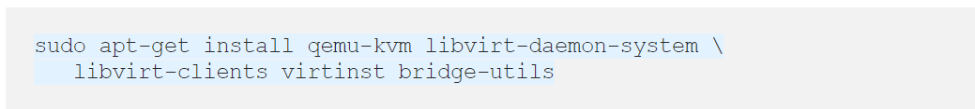

Test that it’s working with virsh list --all this should show you an empty listing, but a listing none-the-less:

# virsh list --all

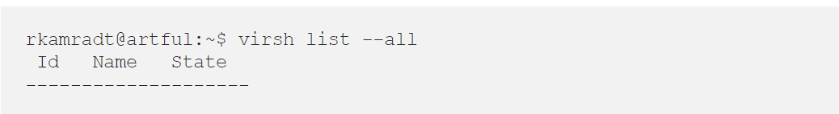

The next thing we’re going to do is replace the default bridging.

For performance reasons, it is recommended to disable netfilter on bridges in the host. To do that, create a file called . vim/etc/sysctl.d/bridge.conf and fill it in with this:

# vim/etc/sysctl.d/bridge.conf

open the configuration file and add this :

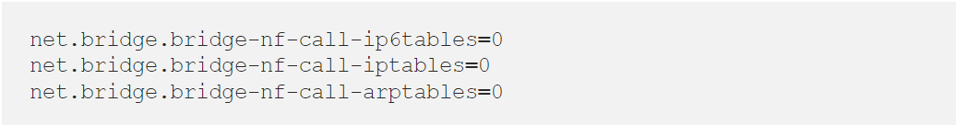

Then create a file called  vim /etc/udev/rules.d/99-bridge.rules and add this line:

# vim /etc/udev/rules.d/99-bridge.rules



Next, we need to disable the default networking that KVM installed for itself. You can use ip to see what the default network looks like:

# ip link

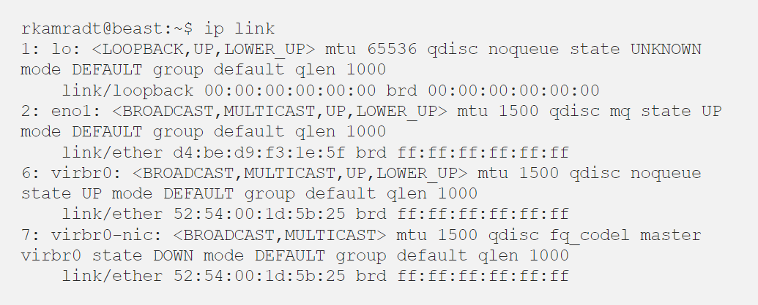

The entries virbr0 and virbr0-nic are what KVM installs by default

Here’s how to remove the default KVM network:

# virsh net-destroy default

# virsh net-undefine default



Now you can run ip again and the virbr0 and virbr0-nic should be gone

# ip link

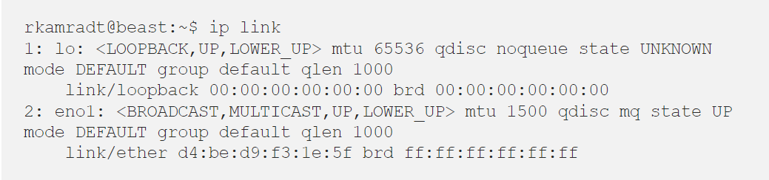

If they are not, you can remove them with:

# ip link delete virbr0 type brigde

#  ip link delete virbr0-nic

Next, we will need to set up a bridge to use when we create a VM

# vim /etc/netplan/00-installer-config.yaml

Open the configuration file and edit

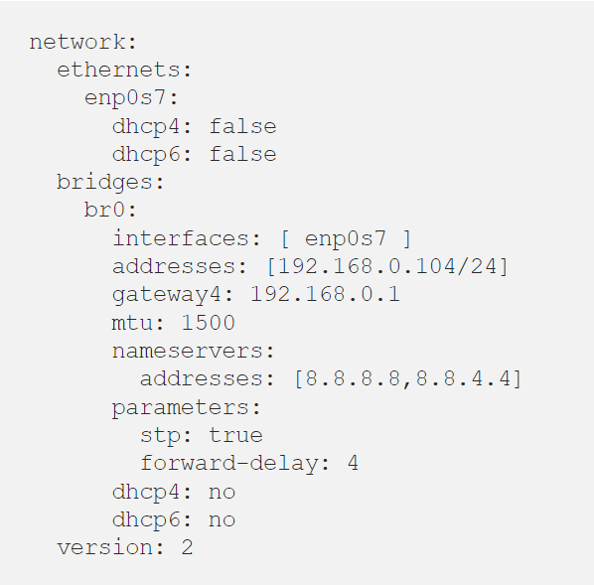This is what mine looks like after editing:

Now run sudo netplan apply to apply your new configuration

# netplan apply

You can use the ip command to inspect that it looks correct:

# ip link

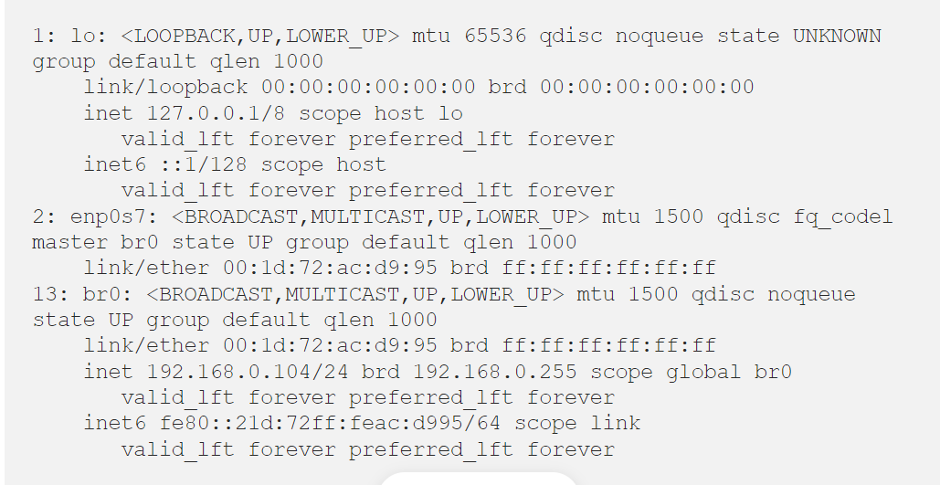

Note that the br0 entry now has the IP address and the enp0s7 entry now has master br0 to show that it belongs to the bridge.

Now we can make KVM aware of this bridge. create a scratch XML file called host-bridge.xml and insert the following

# vim host-bridge.xml

Open this file add some xml content

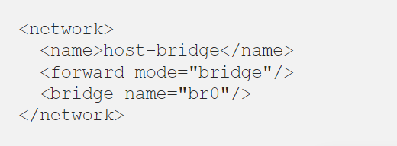

Use the following commands to make that our default bridge for VMs:

# virsh net-define host-bridge.xml

# virsh net-start host-bridge

# virsh net-autostart host-bridge

And then list the networks to confirm it is set to autostart:

# virsh net-list –all

